Diplom Søndag 25 April 2021

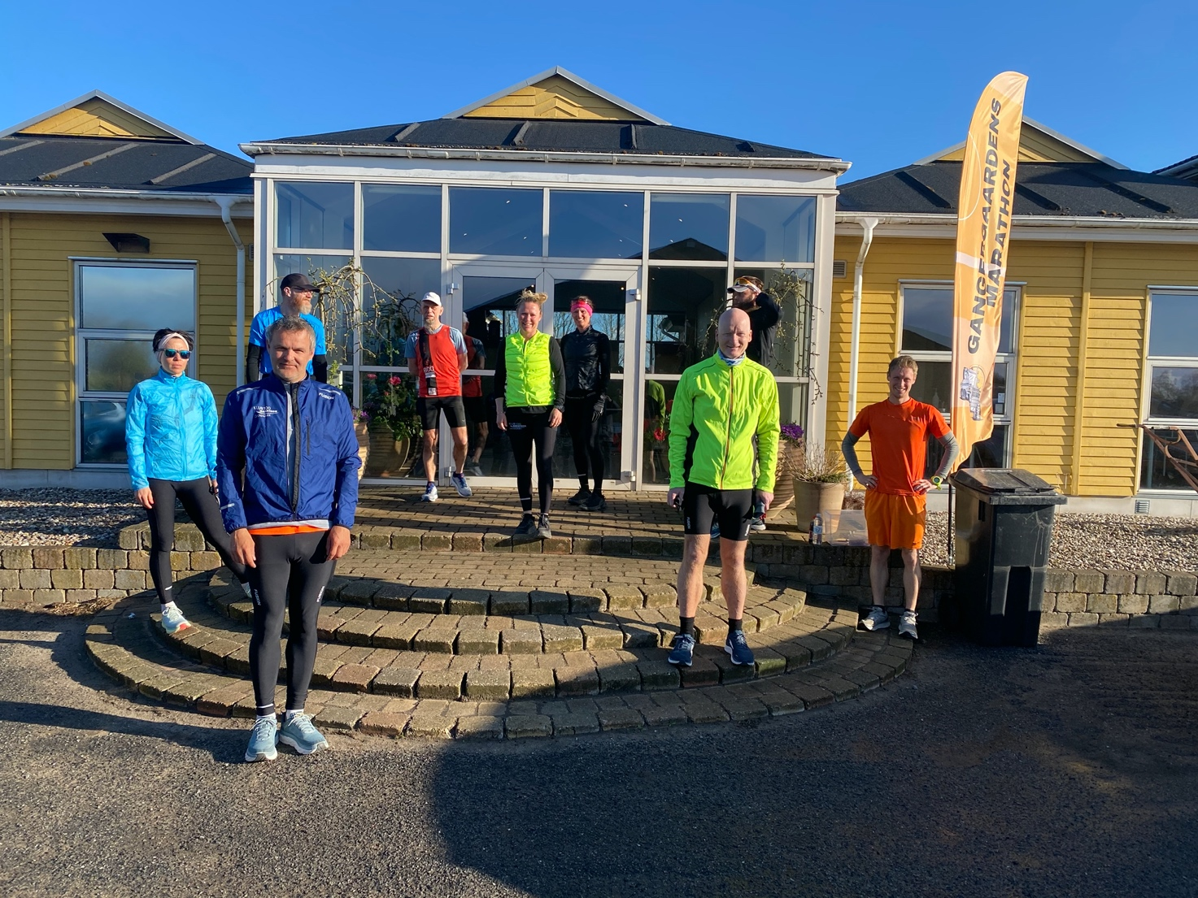

- Luise Gangergaard 4:22:58
- Britt Jørgensen 4:22:58
- Ole Caffel 3:37:28
- Ulrik Pihl 3:49.11
- Harry Cilleborg 4:22:58
- David Bredo 3:49:11
- Jari Hiltunen 3:47:35
- Betina Sørensen 3:46:41
- Jens Broed 4:22:56

