DIPLOM

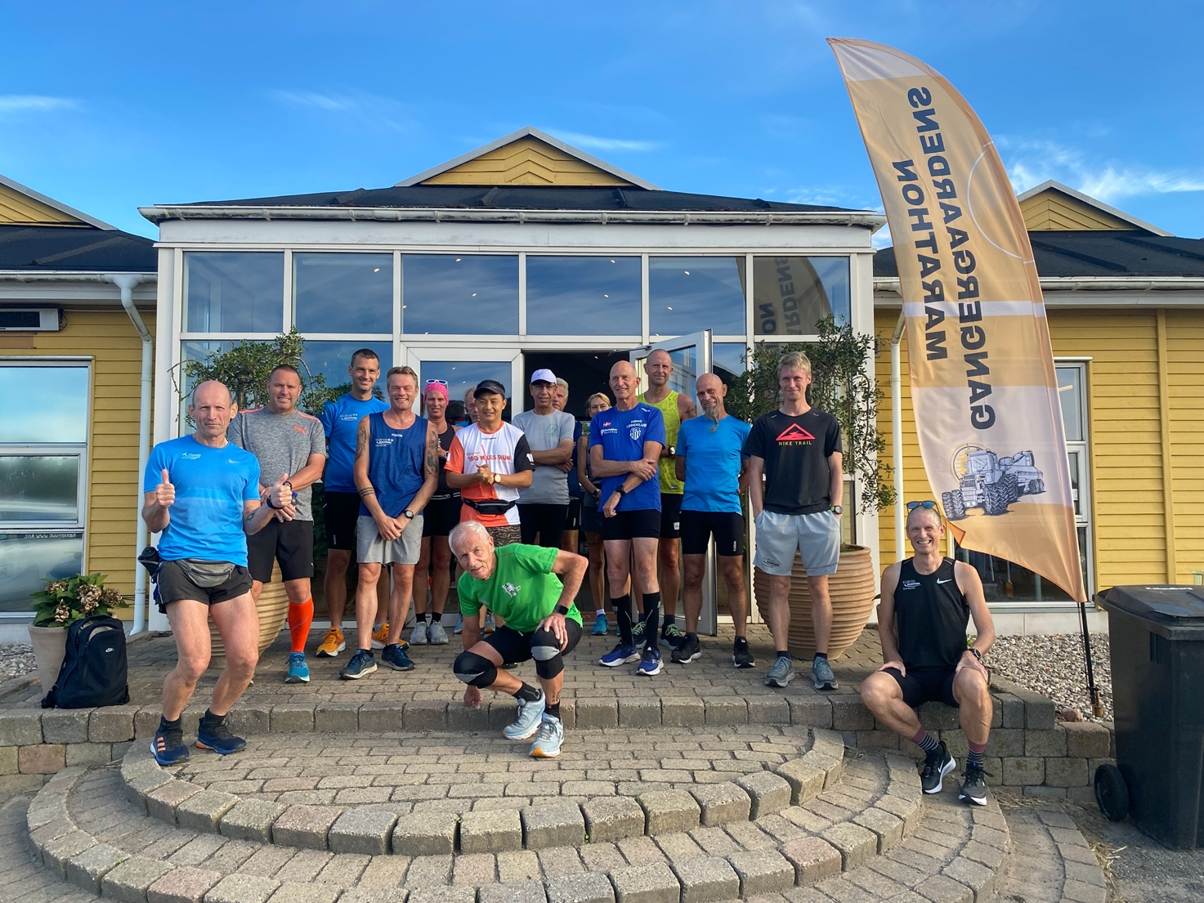

Lørdag 3 September 2022 - kl. 08.

Marathon. TID
Bo Johansen 4:36:48
Britt Jørgensen 4:36:48
Claus Blaabjerg 3:58:41
David Bredo 3:58:41
Hans Christian Jensen 4:42:33
Harry Cilleborg 4:36:48
Jimmi Bjerregaard 5:29:34
Kurt Olsen 4:36:48
Lasse Kirkelykke 3:58:41
Mie Pedersen 3:37:48
Nils Sonqvist 4:47:53
Ove Pedersen 4:46:53
Per Christoffersen. " 200 " 3:57:14
Peter Berg 4:42:33
Peter Grøn 4:45:09
Zamel Zhaian 4:36:48

