Diplom 25 September 2021

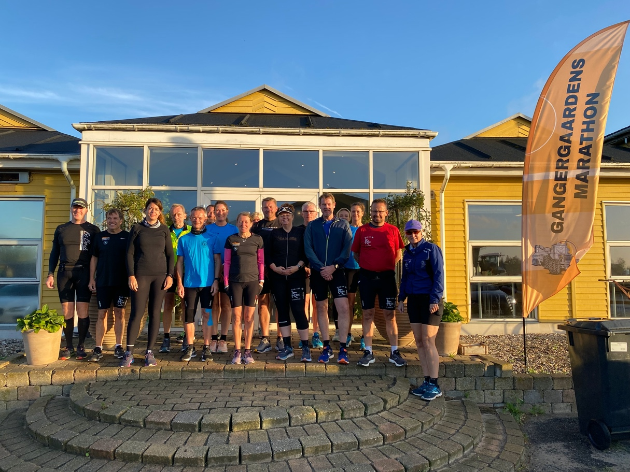
Marathon 3. Kenneth Weiglin - 1:54:46
1. Luise Gangergaard - 4:53:15 4. Paw Pedersen - 1:56:17
2. Anette Fog - 4:53:15 5. Winni Jeppesen - 1:54:45
3. Kurt Olsen - 4:53:15 6. Arne Oliver Hansen - 1:54:26
4. Maja Klausen - 4:53:15 7. Sandie Olesen - 1:56:29
5. Rene Falk Jensen - 4:53:15 8. Bo Bøgh - 1:56:27
6. Carsten Toft - 4:53:15 9. Kate Pedersen - 2:18:49
Halv Marathon 10. Dorthe Møller - 2:50:57
1. Mette Fly - 2:14:10 11. Jørgen Nielsen - 2:50:58
2. Jeanette Wly - 2:10:07 12. Steen Dahl - 2:08:38

