DIPLOM - Lørdag 2 Juli 2022

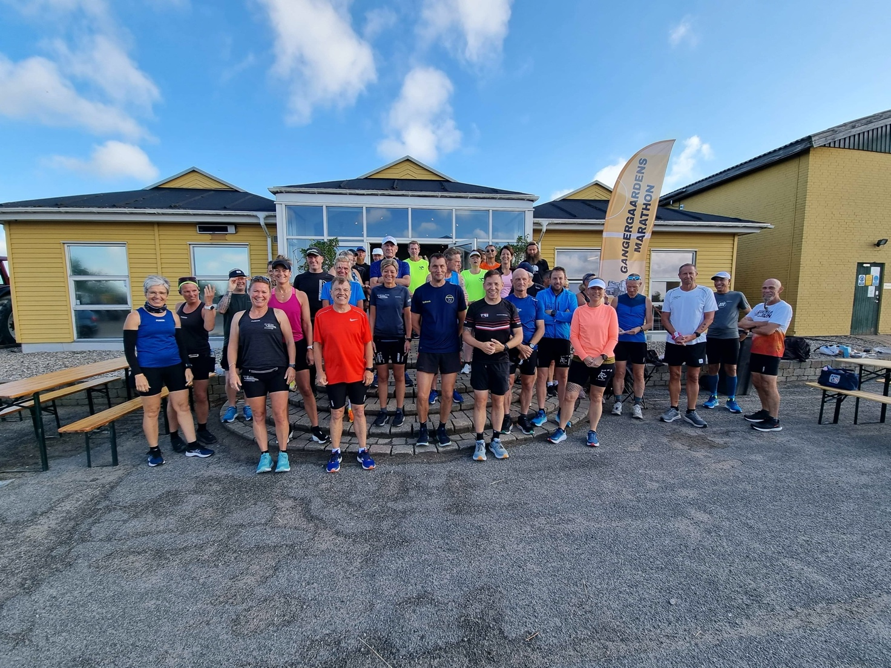

Marathon. Kl 8
Annette Eriksen 4:13:50
Bo Johansen 4:50:51
Bouchra Eriksen 3:28:55
Britt Jørgensen 5:00:55
Carsten Toft 4:26:26
Claus Blaabjerg 4:20:59
Dan Kristensen 4:38:34
David Bredo 4:20:59
Hans Christian Jensen 5:00:55
Harry Cilleborg 5:00:55
Henrik Madsen 5:00:55
Henrik Hoplarik Franijeur 5:00:55
Jens Mogensen 4:07:57
Jesper Carls 5:25:38
Kenneth Sommer 2:59:02
Kenneth Weiglin DNS
Kristian Kjeldsen 3:28:55
Kirsten Bonde 5:00:55
Kurt Olsen 5:00:55
Maja Florens Scheel 5:00:55
Mette Fly 5:00:55
Lars Jakobsen 4:38:25
Lars Jensen 5:29:17
Leon Elstrøm 5:00:55
Lise Friis 5:00:55
Luise Gangergaard nr 300 5:00:55
Paw Jeppesen 4:20:59
Rene Falk Jensen 5:00:55
Peter Jakobsen 5:00:55
Sandie Olesen 5:00:55
Sisse Lykke Weinreich 5:29:19
Sten Ejlersen 4:23:17
Søren Kuhlmann 4:20:59
Thomas B. Jensen 4:18:29
Ulrik Pihl 4:20:59
Zamel Zhaian 4:20:59

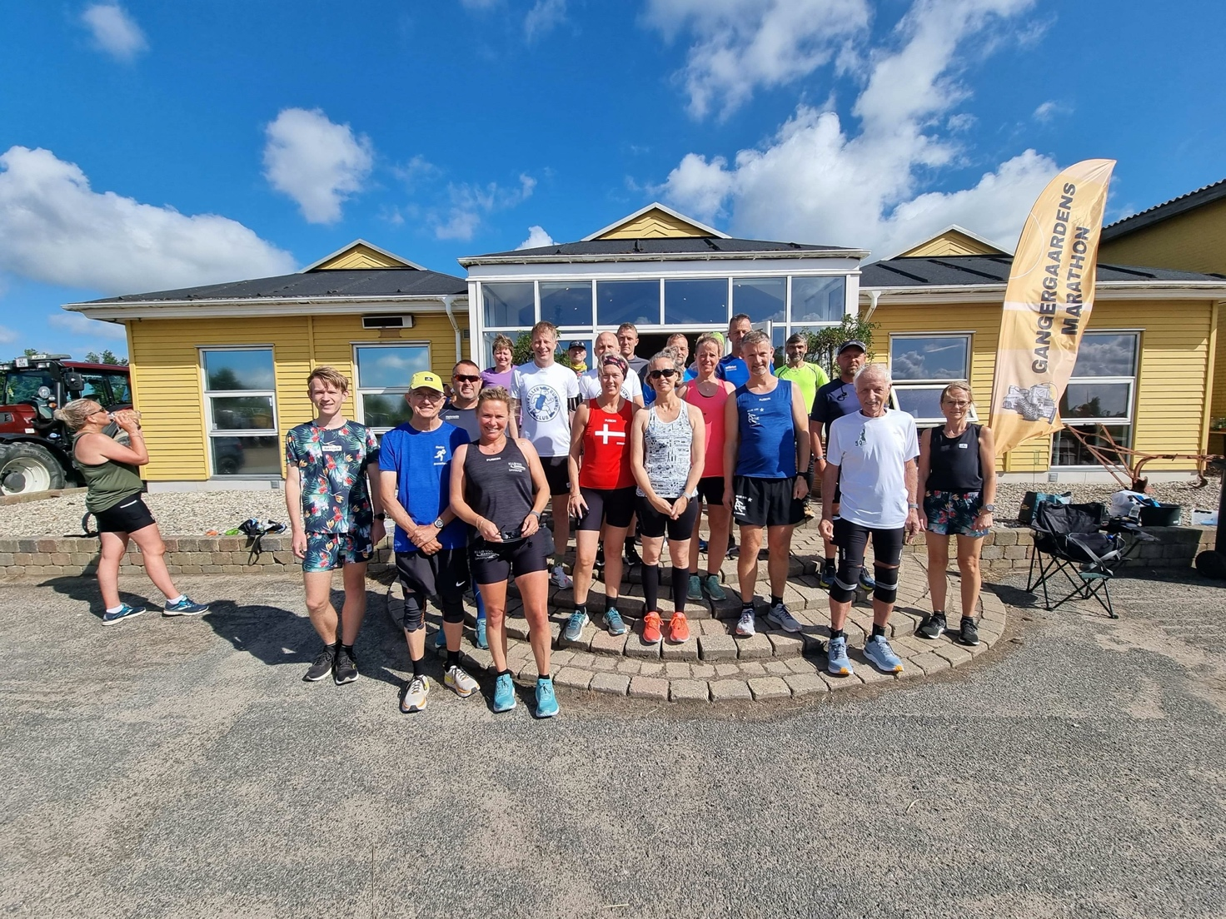

Halv Marathon – kl 10

Anne Pedersen 2:32:56
Annika Andersen 2:40:00
Bettina Voss 2:32:56
Birgitte Grenaa 3:47:55
Bo Bøgh 2:01:59
Brian Feldborg 2:01:57
Claus Lund 2:24:56
Dorte Corvinius 2:32:56
Dorte Møller 2:53:33
Eli Jacobi Nielsen 2:23:54
Ester Mbaruku Nielsen 2:10:32
Eva Pedersen 2:32:56
Jane Andersen 2:20:27
Jeanette Jensen 2:55:42
Jeanette Wly 2:07:36
Jimmi Bjerregaard 2:22:37
Jørgen Nielsen 2:53:33
Kim G. Nørgaard 2:35:03
Lene Louise Jensen 2:24:05
Mikael Jonassen 1:54:33
Morten Andersen 2:09:42
Morten Larsen 2:14:05
Nils Sonqvist 2:23:54
Peter Steenberg 1:49:56
Rasmus Stark 2:08:00
Rene Hansen 1:56:40
Rie Ingmann 2:57:03
Sillas N. Chortzen 1:36:58
Tarina Kristensen 3:25:40
Tina Beckmann 2:10:32
Trine Korsholm 2:26:58
Ufuk Gedik

